**Guangxi Association website detail design**

Author: liangjianquan

Date: 2022-11-09

Version 1.0

Executive overview

The website mainly introduces the Guangxi Association and shows recent developments and news releases.

# Online repositories

GitHub is going to be our Control Version System CVS.

A unified repository was created and includes all team members.

<https://github.com/liangjianquan82/Guangxitongxianghui-web>

# Communications strategy

Zoom is used for regular meetings. A WeChat Group was created to exchange text messages.

# Areas of responsibility

**The team**

Ruyuan Fan

Jianquan Liang

**Client contact**

the primary client contact : Ruyuan Fan

**Reports**

Documents and Meeting Minutes:Jianquan Liang

**Notetaker**

# Contact information

|  |  |
| --- | --- |
| email.png | phone.jpg |
| ruyuanfan@gmail.com | 438-888-6306 |
| liangjianquan82@gmail.com | 438-728-3606 |

# Project plan

# Appendices

## FlowChart

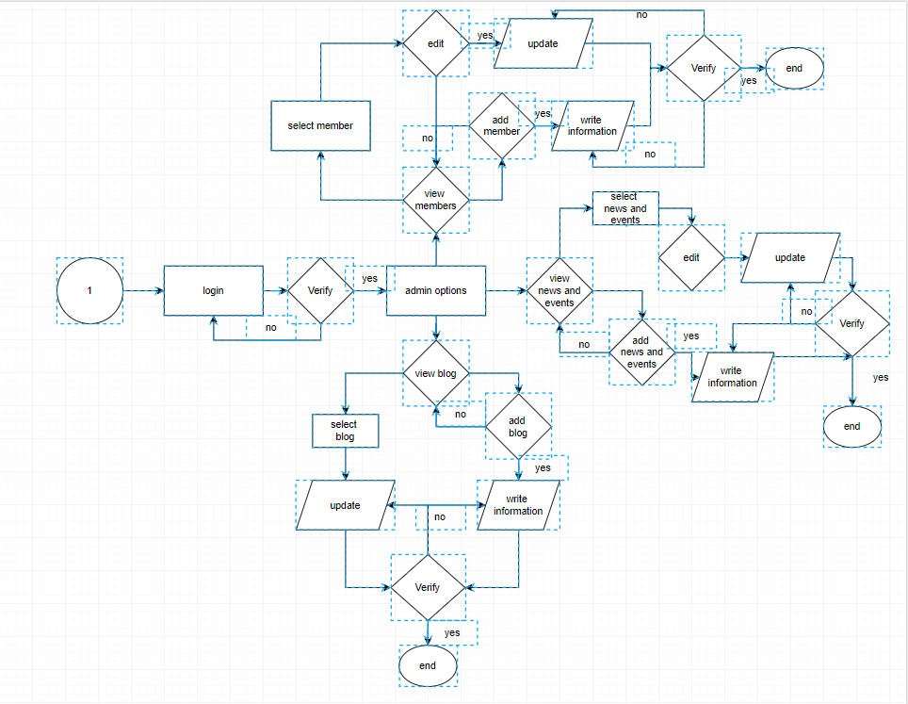

## **UML diagram**

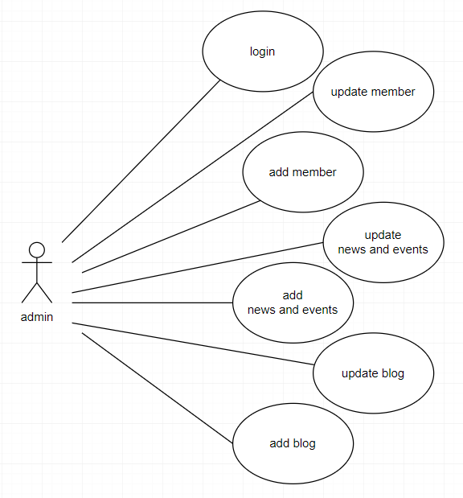

## **Use Case**

**Use Case documents:**

|  |  |  |  |
| --- | --- | --- | --- |
| **Use Case ID:** | **UC-Login_admin** | | |
| **Use Case Name:** | Admin Log in | | |
| **Created By:** | Liang | **Last Updated By:** | Liang |
| **Date Created:** | 2023/04/03 | **Last Revision Date:** | 2023/04/03 |
| **Actors:** | Admin (Primary) /Database (Secondary) | | |
| **Description:** | Admin log in by entering he credential | | |
| **Trigger:** | Admin wants to log in | | |
| **Preconditions:** | No | | |
| **Postconditions:** | Admin will be directed to the Admin homepage | | |
| **Normal Flow:** | 1. The Admin enters his credentials 2. Credentials are authenticated by the system 3. The Admin is logged in and directed to the homepage | | |
| **Alternative Flow:** | If the username or password is not correct (does not match those stored in the DB), an error message is displayed. Then, repeat steps 1 to 3 in the normal flow | | |
| **Exceptions:** |  | | |
| **Includes:** | N/ A | | |
| **Frequency of Use:** | On demand | | |
| **Special Requirements:** | N/A | | |
| **Assumptions:** | The user has a computer and is connected to the internet | | |
| **Notes and Issues:** | No | | |

|  |  |  |  |
| --- | --- | --- | --- |
| **Use Case ID:** | **UC-****Update-member** | | |
| **Use Case Name:** | **Update-member** | | |
| **Created By:** | Liang | **Last Updated By:** | Liang |
| **Date Created:** | 2023/04/03 | **Last Revision Date:** | 2023/04/03 |
| **Actors:** | Admin (Primary) /Database (Secondary) | | |
| **Description:** | Admin update member information | | |
| **Trigger:** | update member information | | |
| **Preconditions:** | Admin log in | | |
| **Postconditions:** | Admin will be directed to the member viewpage | | |
| **Normal Flow:** | 1. The Admin select one member 2. Click the modify button 3. Modify member information 4. Verify and submit input information | | |
| **Alternative Flow:** | If the input information is not correct , an error message is displayed. Then, repeat steps 3 in the normal flow | | |
| **Exceptions:** |  | | |
| **Includes:** | N/ A | | |
| **Frequency of Use:** | On demand | | |
| **Special Requirements:** | N/A | | |
| **Assumptions:** | The user has a computer and is connected to the internet | | |
| **Notes and Issues:** | No | | |

|  |  |  |  |
| --- | --- | --- | --- |
| **Use Case ID:** | **UC-Add-member** | | |
| **Use Case Name:** | **Add-member** | | |
| **Created By:** | Liang | **Last Updated By:** | Liang |
| **Date Created:** | 2023/04/03 | **Last Revision Date:** | 2023/04/03 |
| **Actors:** | Admin (Primary) /Database (Secondary) | | |
| **Description:** | Admin add member information | | |
| **Trigger:** | Add member information | | |
| **Preconditions:** | Admin log in | | |
| **Postconditions:** | Admin will be directed to the member viewpage | | |
| **Normal Flow:** | 1.Click the add button  2.add member information  3.Verify and submit input information | | |
| **Alternative Flow:** | If the input information is not correct , an error message is displayed. Then, repeat steps 2 in the normal flow | | |
| **Exceptions:** |  | | |
| **Includes:** | N/ A | | |
| **Frequency of Use:** | On demand | | |
| **Special Requirements:** | N/A | | |
| **Assumptions:** | The user has a computer and is connected to the internet | | |
| **Notes and Issues:** | No | | |

|  |  |  |  |
| --- | --- | --- | --- |
| **Use Case ID:** | **UC-Add-news** | | |
| **Use Case Name:** | **Add-news** | | |
| **Created By:** | Liang | **Last Updated By:** | Liang |
| **Date Created:** | 2023/04/03 | **Last Revision Date:** | 2023/04/03 |
| **Actors:** | Admin (Primary) /Database (Secondary) | | |
| **Description:** | Admin add news information | | |
| **Trigger:** | Add news information | | |
| **Preconditions:** | Admin log in | | |
| **Postconditions:** | Admin will be directed to the news viewpage | | |
| **Normal Flow:** | 1..Click the add button  2.add member information  3.Verify and submit input information | | |
| **Alternative Flow:** | If the input information is not correct , an error message is displayed. Then, repeat steps 2 in the normal flow | | |
| **Exceptions:** |  | | |
| **Includes:** | N/ A | | |
| **Frequency of Use:** | On demand | | |
| **Special Requirements:** | N/A | | |
| **Assumptions:** | The user has a computer and is connected to the internet | | |
| **Notes and Issues:** | No | | |

|  |  |  |  |
| --- | --- | --- | --- |
| **Use Case ID:** | **UC-Update-news** | | |
| **Use Case Name:** | **Update-news** | | |
| **Created By:** | Liang | **Last Updated By:** | Liang |
| **Date Created:** | 2023/04/03 | **Last Revision Date:** | 2023/04/03 |
| **Actors:** | Admin (Primary) /Database (Secondary) | | |
| **Description:** | Admin update news information | | |
| **Trigger:** | update news information | | |
| **Preconditions:** | Admin log in | | |
| **Postconditions:** | Admin will be directed to the news viewpage | | |
| **Normal Flow:** | 1. The Admin select one news 2. Click the modify button 3. Modify news information 4. Verify and submit input information | | |
| **Alternative Flow:** | If the input information is not correct , an error message is displayed. Then, repeat steps 3 in the normal flow | | |
| **Exceptions:** |  | | |
| **Includes:** | N/ A | | |
| **Frequency of Use:** | On demand | | |
| **Special Requirements:** | N/A | | |
| **Assumptions:** | The user has a computer and is connected to the internet | | |
| **Notes and Issues:** | No | | |

|  |  |  |  |
| --- | --- | --- | --- |
| **Use Case ID:** | **UC-Add-blog** | | |
| **Use Case Name:** | **Add-blog** | | |
| **Created By:** | Liang | **Last Updated By:** | Liang |
| **Date Created:** | 2023/04/03 | **Last Revision Date:** | 2023/04/03 |
| **Actors:** | Admin (Primary) /Database (Secondary) | | |
| **Description:** | Admin add blog information | | |
| **Trigger:** | Add news information | | |
| **Preconditions:** | Admin log in | | |
| **Postconditions:** | Admin will be directed to the blog viewpage | | |
| **Normal Flow:** | 1..Click the add button  2.add blog information  3.Verify and submit input information | | |
| **Alternative Flow:** | If the input information is not correct , an error message is displayed. Then, repeat steps 2 in the normal flow | | |
| **Exceptions:** |  | | |
| **Includes:** | N/ A | | |
| **Frequency of Use:** | On demand | | |
| **Special Requirements:** | N/A | | |
| **Assumptions:** | The user has a computer and is connected to the internet | | |
| **Notes and Issues:** | No | | |

|  |  |  |  |
| --- | --- | --- | --- |
| **Use Case ID:** | **UC-Update-blog** | | |
| **Use Case Name:** | **Update-****blog** | | |
| **Created By:** | Liang | **Last Updated By:** | Liang |
| **Date Created:** | 2023/04/03 | **Last Revision Date:** | 2023/04/03 |
| **Actors:** | Admin (Primary) /Database (Secondary) | | |
| **Description:** | Admin update blog information | | |
| **Trigger:** | update blog information | | |
| **Preconditions:** | Admin log in | | |
| **Postconditions:** | Admin will be directed to the news viewpage | | |
| **Normal Flow:** | 1.The Admin select one blog  2.Click the modify button  3.Modify news information  4.Verify and submit input information | | |
| **Alternative Flow:** | If the input information is not correct , an error message is displayed. Then, repeat steps 3 in the normal flow | | |
| **Exceptions:** |  | | |
| **Includes:** | N/ A | | |
| **Frequency of Use:** | On demand | | |
| **Special Requirements:** | N/A | | |
| **Assumptions:** | The user has a computer and is connected to the internet | | |
| **Notes and Issues:** | No | | |

## **Class diagram**

## **User Stories and Story Test Criteria (Acceptance Tests)**

## **User Story Map（**Trello**）**

## **Interfacedesign(Figma)**